Email Archiving in Info-Organiser Version 12

Filing Emails
- Ensure the Info-Organiser plug-in is installed in the Outlook toolbar (refer diagram below).
If not installed, then consult your IT provider or install using the following link:
  - Microsoft Office Addins (Office: Word, Excel, Outlook 2010-2016)
- Select the email(s). Multiple emails can be selected by holding the [SHIFT] key or [CTRL] key.
Note: the above picture is in Outlook.
- Choose Copy or Move
  - Copy takes a copy of the email and the original remains within your Outlook folders
  - Move moves the email from Outlook to Info-Organiser, deleting it from Outlook
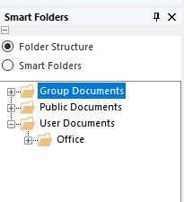
- Located on the left-hand side of Info-Organiser, there will be a smart folder section. Select Folder Structure. Then choose the folder to file the email. See picture below.
- Afterwards on the bottom right hand corner you can index the email.
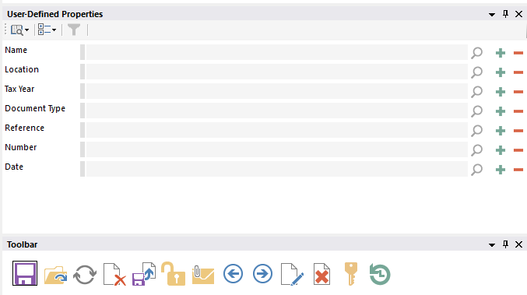
- Once completed click the SAVE icon. All metadata is now captured and searchable.

Searching for Emails
All email metadata is captured by Info-Organiser. This metadata is then available for searching.
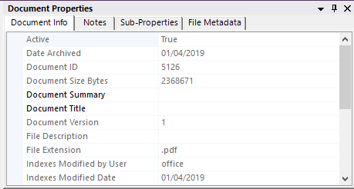
Refer Search Screen Example below:
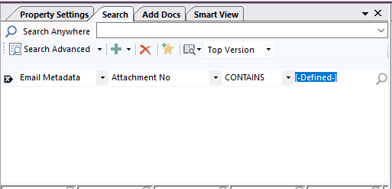
Step 3
Step 2
Step 1
- Choose Email Metadata
- Choose a Field
- Choose a constraint from the drop-down list
Note: The Info-Organiser search engine supports your filtering search queries by options such as adding fields and using the AND, OR or NOT feature:
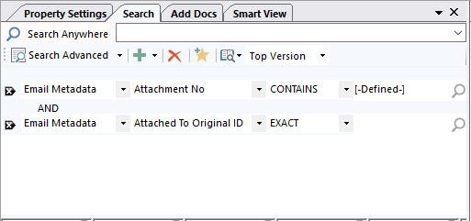

Previewing Emails

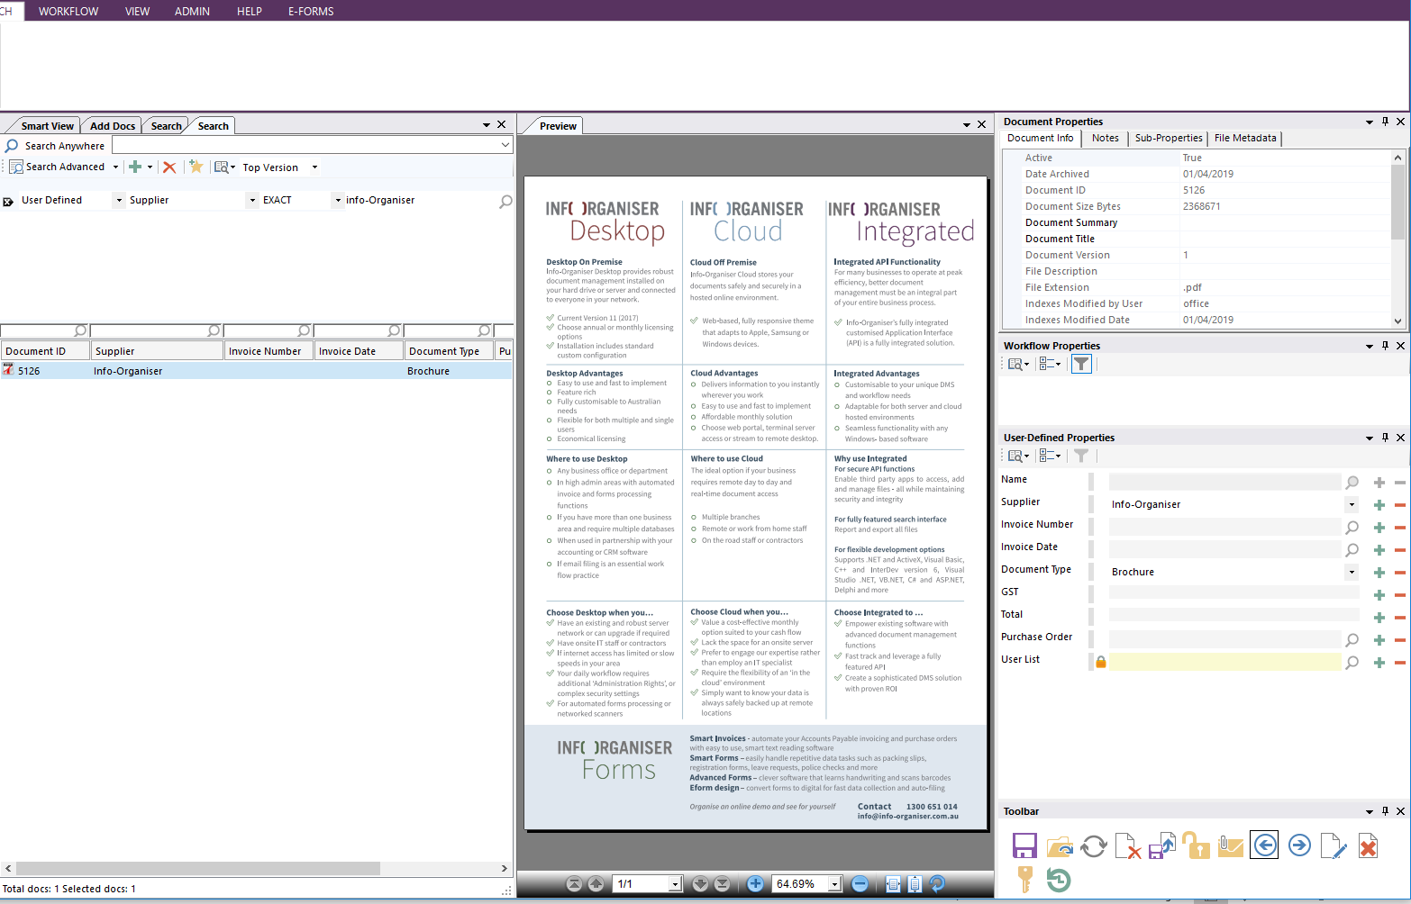
Email’s can be previewed straight from the search screen for fast selection.

